Lecture 2.

Morphology and ultrastructure of bacteria. Classification, morphology and ultrastructure of spirochetes, rickettsia, chlamydia, mycoplasma and actinomycetes

The purpose of the lecture: To inform students about the morphology and ultrastructure of bacteria. Explain to them the classification, morphology and ultrastructure of spirochetes, rickettsiae, chlamydia, mycoplasma and actinomycetes, as well as species that are pathogenic to humans.

Lecture plan:
1. Morphology and ultrastructure of prokaryotic microorganisms
- Morphology and basic forms of bacteria. Bacterial cell ultrastructure. The structure of the cell wall of Gram-positive and Gram-negative bacteria. The cell wall of acid-fast bacteria. Bacteria without a cell wall. Stable (nucleoid, cytoplasm, ribosome, cell membrane - cytoplasmic membrane, cell wall, mucous layer) and unstable (capsule, flagella, intracellular appendages, pili and spores) components of the cell.
- Classification, morphology, ultrastructure, tinctorial properties of spirochetes and types of pathogens for humans.
- Classification, morphology, ultrastructure and types of pathogens for rickettsiae in humans.
- Classification, morphology, ultrastructure, tinctorial features and types of human pathogens of chlamydia.
- Classification, morphology, ultrastructure of mycoplasmas and types of pathogens for humans.
- Classification, morphology, ultrastructure and types of human pathogens of actinomycetes.

Bacteria are classified by shape into three basic groups: cocci, bacilli, and spirochetes. The cocci are round, the bacilli are rods, and the spirochetes are spiral-shaped. Some bacteria are variable in shape and are said to be pleomorphic (heterogeneous shape). The shape of a bacterium is determined by its rigid celi wall. The microscopic appearance of a bacterium is one of the most important criteria used in its Identification.

In addition to their characteristic shapes, the arrangement of bacteria is important. For example, certain cocci occur in pairs (diplococci), some in chains (streptococci), and others in grapelike clusters (staphylococci). These arrangements are determined by the orientation and degree of attachment of the bacteria at the time of celi division. The arrangement of rods and spirochetes is medically less important and is not described in this introductory chapter.
Bacteria range in size from about 0.2 to 5 pm. The smallest bacteria (Mycoplasma) are about the same size as the largest viruses (poxviruses) and are the smallest organisms capable of existing outside a hoşt. The longest bacteria are the size of some yeasts and human red blood cells (7 pm).

Bacterial morphology. A: Cocci in clusters (e.g., Staphylococcus; A-1); in chains (e.g., Streptococcus; A-2); in pairs with pointed ends (e.g., Streptococcus pneumoniae; A-3); in pairs with kidney bean shape (e.g., Neisseria; A-4). B: Rods (bacilli): with square ends (e.g., Bacillus; B-1); with rounded ends (e.g., Salmonella; B-2); club-shaped (e.g., Corynebacterium; B-3); fusiform (e.g., Fusobacterium; B-4); comma-shaped (e.g., Vibrio; B-5). C: Spirochetes: relaxed coil (e.g., Borrelia; C-1); tightly coiled (e.g., Treponema; C-2).
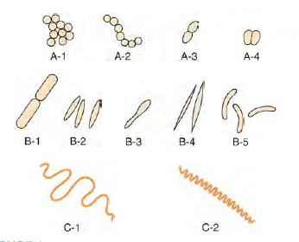

Sizes of representative bacteria, viruses, yeasts, protozoa, and human red cells. The bacteria range in size from Mycoplasma, the smallest, to Bacillus anthracis, one of the largest. The viruses range from poliovirus, one of the smallest, to poxviruses. Yeasts, such as Candida albicans, are generally larger than bacteria. Protozoa have many different forms and a broad size range. HIV, human immunodeficiency virus.
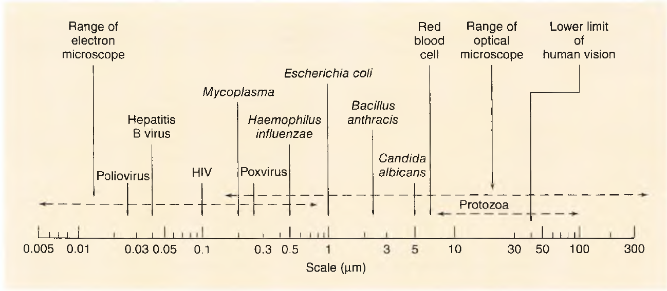
Bacterial Structures
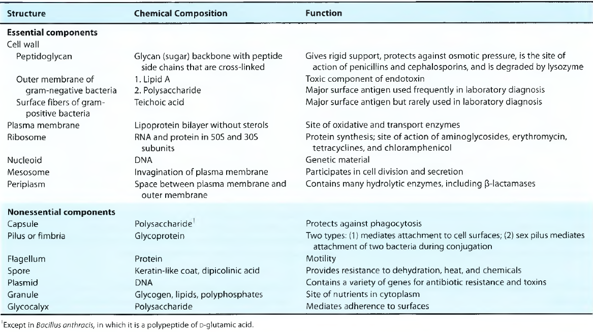

Comparison of Celi Walls of Gram-Positive and Gram-Negative Bacteria
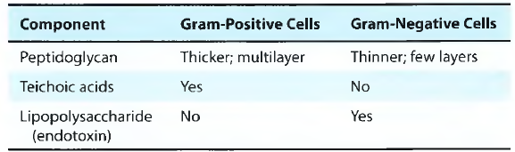

Medically İmportant Bacteria That Cannot Be Seen in the Gram Stain
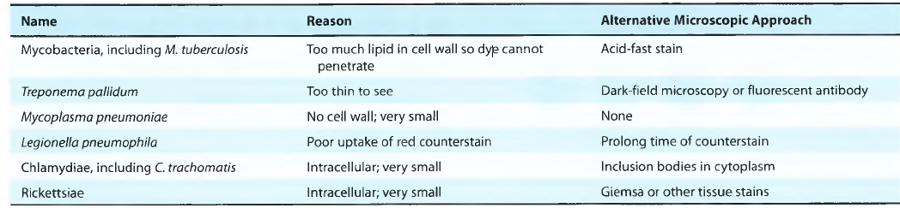
Teichoic acids have many functions:
■ They constitute major surface antigens of those Gram positive species that possess them. In Streptococcus pneumoniae, the teichoic acids bear the antigenic determinants called Forssman antigen. In Streptococcus pyogenes, LTA is associated with the M protein that protrudes from the cell membrane through the peptidoglycan layer. The long M protein molecules together with the LTA form microfibrils that facilitate the attachment of S. pyogenes to animal cells;
■ They are also used as antigen for serological classification of bacteria;
■ They serve as substrates for many autolytic enzymes;
■ They bind magnesium ion and may play a role in supply of this ion to the cell;
■ They play a role in normal functioning of the cell wall and provide an external permeability barrier to Gram-positive bacteria; and
■ Membrane teichoic acid serves to anchor the underlying cell membrane.

Important Features of Spores and Their Medical Implications
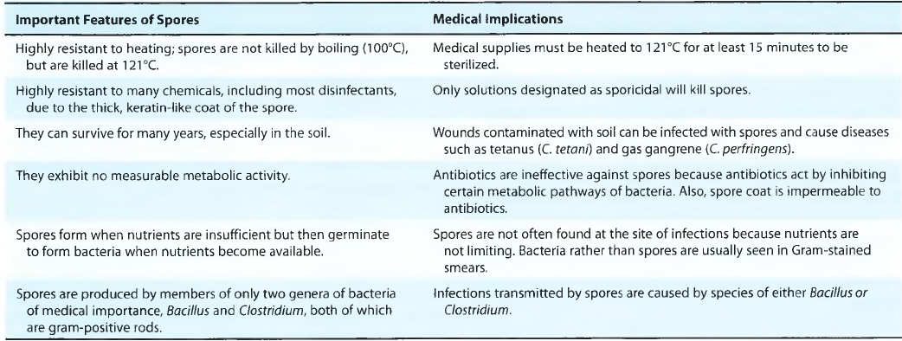

Shape & Size
• Bacteria have three shapes: cocci (spheres), bacilli (rods), and spirochetes (spirals).
• Cocci are arranged in three patterns: pairs (diplococci), chains (streptococci), and clusters (staphylococci).
• The size of most bacteria ranges from 1 to 3 pm. Mycoplasma, the smallest bacteria (and therefore the smallest cells), are 0.2 pm. Some bacteria, such as Borrelia, are as long as 10 pm; that is, they are longer than a human red blood cell, which is 7 pm in diameter.
Bacterial Cell Wall
• All bacteria have a cell wall composed of peptidoglycan except Mycoplasma, which are surrounded only by a cell membrane.
• Gram-negative bacteria have a thin peptidoglycan covered by an outer lipid-containing membrane, whereas gram-positive bacteria have a thick peptidoglycan and no outer membrane. These differences explain why gram-negative bacteria lose the stain when exposed to a lipid solvent in the Gram stain process, whereas gram-positive bacteria retain the stain and remain purple.
The outer membrane of gram-negative bacteria contains endotoxin (lipopolysaccharide, LPS), the main inducer of septic shock. Endotoxin consists of lipid A, which causes the fever and hypotension seen in septic shock, and a poly- saccharide called O antigen, which is useful in laboratory identification.
Between the inner cell membrane and the outer membrane of gram-negative bacteria lies the periplasmic space, which is the location of (3-lactamases—the enzymes that degrade (3-lactam antibiotics, such as penicillin’s and cephalosporins.
Gram staining is an essential procedure that is used in the identification of bacteria. The stain differentiates bacteria into two broad groups:
■ Gram-positive bacteria are those that resist decolorization and retain the primary dye-iodine complex, appearing violet. They have a relatively thick amorphous wall and more acidic protoplasm which are believed to retain the basic violet dye and iodine complex within the cell.
■ Gram-negative bacteria are decolorized by organic solvents and take counterstain, appearing red. The decolorizing agent, such as acetone or ethanol, used during staining disrupts this membranous envelope, and the dye and iodine complex is washed out of Gram-negative bacteria. Gram staining is an essential procedure that is used in the identification of bacteria. The stain differentiates bacteria into two broad groups:
Acid fast staining method consists of following methods:
■ Fixed smears are first stained by a strong carbol fuchsin with the application of heat. Heating facilitates entry of phenolic carbol fuchsin stain into the bacteria.
■ It is then decolorized with 5–20% (depending on the bacteria to be stained) sulfuric acid.
■ It is then counterstained with a contrasting dye, such as methylene blue. The acid-fast bacilli (AFB) retain the red color of carbol fuchsin and appear bright red in stained smears. Pus cells and epithelial cells present in the smear, on other hand,
take up the blue color of the counterstain and appear blue.
Lipopolysaccharide structure. A: The lipopolysaccharide from Salmonella. This slightly simplified diagram illustrates one form of the LPS. Abe, abequose; Gal, galactose; GlcN, glucosamine; Hep, heptulose; KDO, 2-keto-3-deoxyoctonate; Man, mannose; NAG, N-acetylglucosamine; P, phosphate; Rha, l-rhamnose. Lipid A is buried in the outer membrane. B: Molecular model of an Escherichia coli lipopolysaccharide. The lipid A and core polysaccharide are straight; the O side chain is bent at an angle in this model.
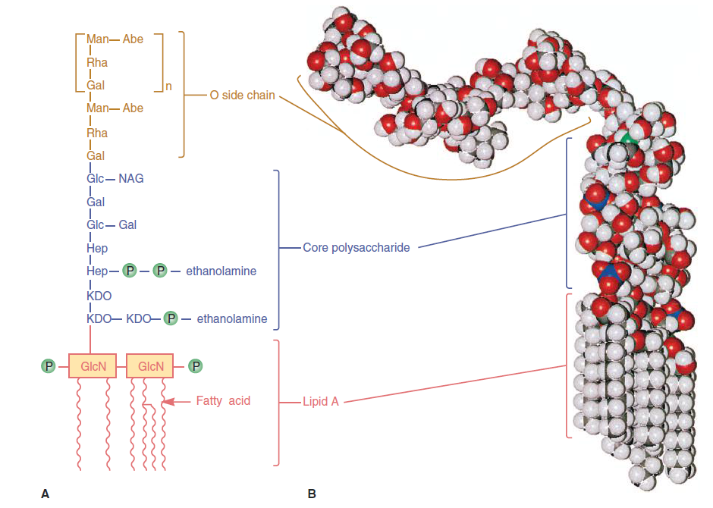

Peptidoglycan is found only in bacterial cells. İt is a network that covers the entire bacterium and gives the organism its shape. İt is composed of a sugar backbone (glycan) and pep- tide side chains (peptido). The side chains are cross-linked by transpeptidase—the enzyme that is inhibited by penicillin’s and cephalosporins.
The cell wall of mycobacteria (e.g., M. tuberculosis) has more lipid than either the gram-positive or gram-negative bacteria. As a result, the dyes used in the Gram stain do not penetrate into (do not stain) mycobacteria. The acid-fast stain does stain mycobacteria, and these bacteria are often called acid-fast bacilli (acid-fast rods).
• Lysozymes kill bacteria by cleaving the glycan backbone of peptidoglycan.
• The cytoplasmic membrane of bacteria consists of a phospho- lipid bilayer (without sterols) located just inside the peptidoglycan. İt regulates active transport of nutrients into the cell and the secretion of toxins out of the cell.
Gram Stain
• Gram stain is the most important staining procedure. Gram- positive bacteria stain purple, whereas gram-negative bacteria stain pink. This difference is due to the ability of gram-positive bacteria to retain the crystal violet-iodine comp\ex in the presence of lipid solvent, usually acetone-alcohol. Gram-negative bacteria, because they have an outer lipid-containing membrane and thin peptidoglycan, lose the purple dye when treated with acetone-alcohol. They become colorless and then stain pink when exposed to a red dye such as safranin.
• Not all bacteria can be visualized using Gram stain. Some important human pathogens, such as the bacteria that cause tuberculosis and syphilis, cannot be seen using this stain.
Bacterial DNA
• The bacterial genome typically consists of a single chromo- some of circular DNA located in the nucleoid.
• Plasmids are extrachromosomal pieces of circular DNA that encode both exotoxins and many enzymes that cause antibiotic resistance.
• Transposons are small pieces of DNA that move frequently between chromosomal DNA and plasmid DNA. They carry antibiotic-resistant genes.
Bacterial cell wall structure. A: Cell walls of gram-positive and gram-negative bacteria. Note that the peptidoglycan in gram- positive bacteria is much thicker than in gram-negative bacteria. Note also that only gram-negative bacteria have an outer membrane containing endotoxin (lipopolysaccharide [LPS]) and thus have a periplasmic space where p-lactamases are found. Several important gram-positive bacteria, such as Staphylococci and streptococci, have teichoic acids. (Reproduced with permission from Ingraham JL, Maaloe O, Neidhardt FC. Oowth of the Bacterial Cell. Sunderland, MA: Sinauer Associates: 1983.) B: Cell wall of Mycobacterium tuberculosis: Note the layers of mycolic acid and arabinoglycan that are present in members of the genus Mycobacterium but not in most other genera of bacteria.

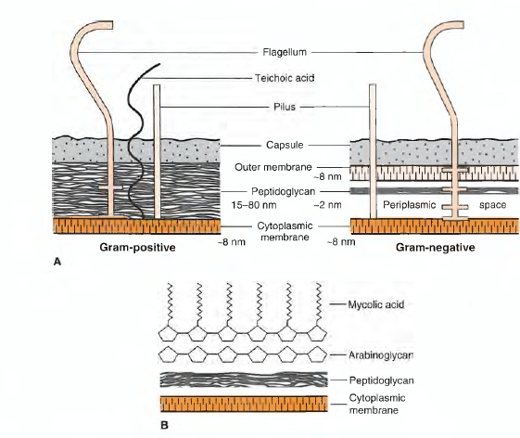
Molecular representation of the envelope of a gram-negative bacterium. Ovals and rectangles represent sugar residues, and circles depict the polar head groups of the glycerophospholipids (phosphatidylethanolamine and phosphatidylglycerol). The core region shown is that of Escherichia coli K-12, a strain that does not normally contain an O-antigen repeat unless transformed with an appropriate plasmid. MDO, membrane-derived oligosaccharides.
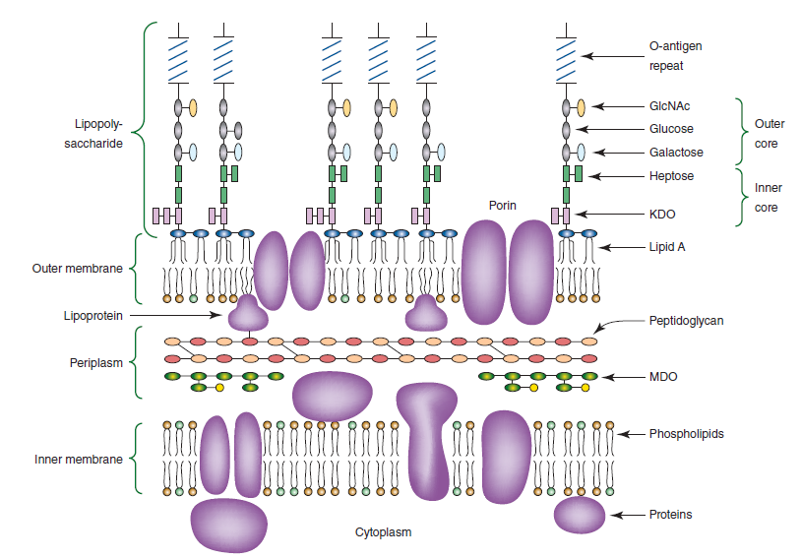

A: Teichoic acid structure. The segment of a teichoic acid made of phosphate, glycerol, and a side chain, R. R may represent d-alanine, glucose, or other molecules. B: Teichoic and lipoteichoic acids of the gram-positive envelope.
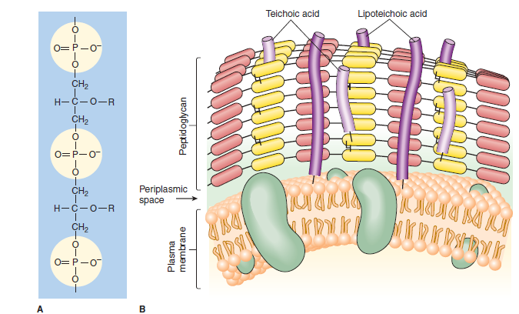
Peptidoglycan structure. A: Peptidoglycan is composed of a glycan chain (NAM and NAG), a tetrapeptide chain, anda cross- link (peptide interbridge). B: İn the celi wall, the peptidoglycan forms a multilayered, three-dimensional structure. NAG, A/-acetylglucosamine; NAM, /V-acetylmuramic acid.
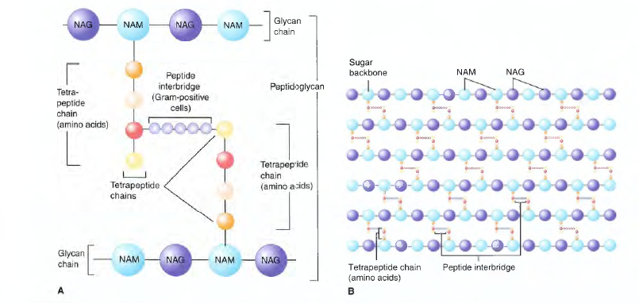
Bacterial plasma membrane structure. This diagram of the fluid mosaic model of bacterial membrane structure shown the integral proteins (green and red) floating in a lipid bilayer. Peripheral proteins (yellow) are associated loosely with the inner membrane surface. Small spheres represent the hydrophilic ends of membrane phospholipids and wiggly tails, the hydrophobic fatty acid chains. Other membrane lipids such as hopanoids (purple) may be present. For the sake of clarity, phospholipids are shown proportionately much larger size than in real membranes. (Reproduced with permission from Willey JM, Sherwood LM, Woolverton CJ [editors]: Prescott, Harley, and Klein’s Microbiology, 7th ed. McGraw-Hill; 2008. © The McGraw-Hill Companies, Inc.)
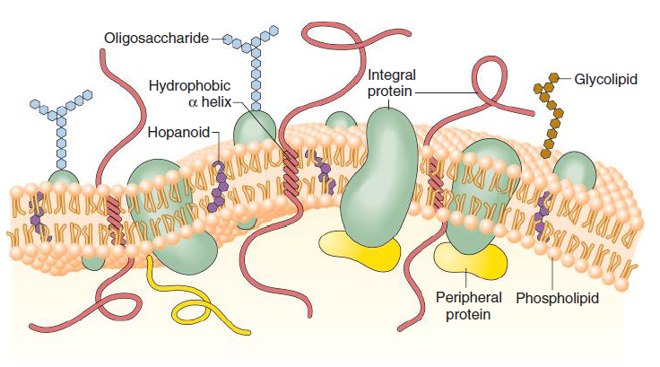

Structures External to the Cell Wall
• Capsules are antiphagocytic; that is, they limit the ability of neutrophils to engulf the bacteria. Almost all capsules are com- posed of polysaccharide; the polypeptide capsule of anthrax bacillus is the only exception. Capsules are also the antigens in several vaccines, such as the pneumococcal vaccine. Antibodies against the capsule neutralize the antiphagocytic effect and allow the bacteria to be engulfed by neutrophils. Opsonization is the process by which antibodies enhance the phagocytosis of bacteria.
The capsule has various functions:
■ It contributes to invasiveness of bacteria by protecting the bacteria from phagocytosis.
■ It also prevents bacteria from generating immune response in infected hosts.
■ It facilitates adherence of bacteria to surfaces. Streptococcus mutans, for example, owes its capacity to the glycocalyx to ■ adhere tightly to tooth enamel to its glycocalyx.
■ It plays a role in the formation of biofilms.
■ The glycocalyx layer of the capsule may also play a role in resistance to desiccation.
Chemical Composition of the Extracellular Polymer in Selected Bacteria
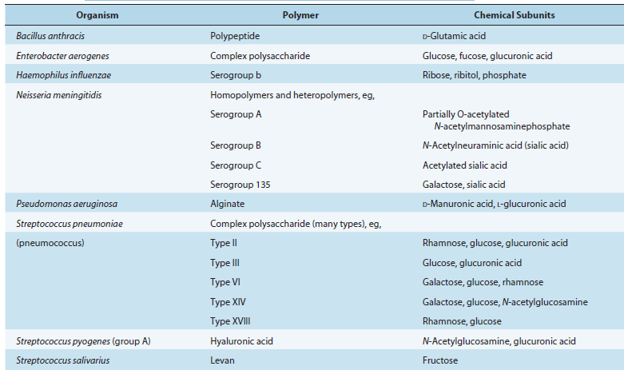

• Pili are filaments of protein that extend from the bacterial surface and mediate attachment of bacteria to the surface of human cells. A different kind of pilus, the sex pilus, functions in conjugation.
• The glycocalyx is a polysaccharide "slime layer" secreted by certain bacteria. İt attaches bacteria firmly to the surface of human cells and to the surface of catheters, prosthetic heart valves, and prosthetic hip joints.
Flagella
Bacterial flagella are thread-like appendages intricately embedded in the cell envelope. These structures are responsible for conferring motility to the bacteria. The arrangement of flagella varies between different bacterial species. Depending on the arrangement, flagella can be of the following types:
■ Monotrichous (single polar fl agellum), e.g., Vibrio cholerae.
■ Lophotrichous (multiple polar fl agella), e.g., Spirilla.
■ Peritrichous (fl agella distributed over the entire cell), e.g., Salmonella Typhi, E.coli, etc.
■ Amphitrichous (single fl agellum at both the ends), e.g., Spirillum minus
Bacterial Spores
• Spores are medically important because they are highly heat resistant and are not killed by many disinfectants. Boiling will not kill spores. They are formed by certain gram-positive rods, especially Bacillus and Clostridium species.
• Spores have a thick, keratin-like coat that allows them to survive for many years, especially in the soil. Spores are formed when nutrients are in short supply, but when nutrients are restored, spores germinate to form bacteria that can cause disease. Spores are metabolically inactive but contain DNA, ribosomes, and other essential components.
Classification of Medically Important Bacteria
The classification of bacteria is based on various criteria, such as the nature of the cell wall, staining characteristics, ability to grow in the presence or absence of oxygen, and ability to form spores.
The criterion currently used is the base sequence of the genome DNA. Several bacteria have been reclassified based on this information.
